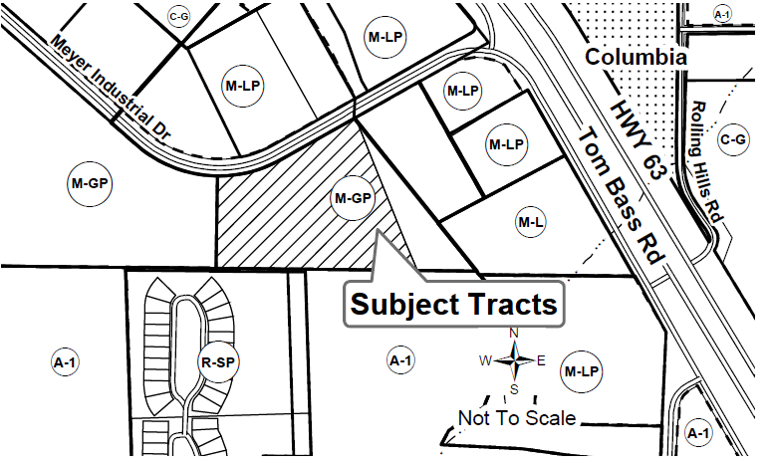
NOTICE OF PUBLIC HEARING
BOONE COUNTY, MISSOURI
Notice is hereby given of a public hearing to be held before the Boone County Planning and Zoning Commission at 7:00 P.M. on Thursday, October 15th, 2026, in Room 214 at the Roger B. Wilson Boone County Government Center, 801 E. Walnut St., Columbia, MO. A second hearing will take place before the Boone County Commission at 7:00 P.M. on Tuesday, October 27th, 2026 in Room 301 at the Roger B. Wilson Boone County Government Center, 801 E. Walnut St., Columbia, MO. The hearings will give all interested parties an opportunity to be heard in relation to the following:
Request by RML Investment Properties LLC to rezone to Planned General Industrial (M-GP) and to approve a review plan for Concorde South Plat 2, Lot 8A on 7.35 acres located at 5080 E Meyer Industrial Drive, Columbia.
The P & Z Commission meeting will also be available by phone, please check our website for additional details at www.boonemo.gov/resource-management/
Questions regarding the above request may be directed to the Boone County Resource Management office at 573-886-4330.
Boone County Planning & Zoning Commission
Eric Kurzejeski, Chairperson

